Lab DLT – Digital lab tools

Note: Double click on the information block at the top of the page and enter: Your name; Lab section; The date; and the name(s) of your lab partner(s). Check the box at the bottom of the block only if you are not in your assigned section but are making up the lab with a different section. Add any notes which your TA might need to know when grading your work (e.g. “smoke was pouring out of the power supply in Activity 2 so perhaps the data is messed up”). You can then get started on the next page.

The digital lab notebook

Computers crash; that’s just a fact of life. Save your work regularly throughout the lab.
Paper is not banned! Before we go into the digital notebook, we want to emphasize that sometimes, it is simply easier to figure out things with paper and pencil. You should always have them available during the lab. Just make sure that you then enter the information on the digital notebook.

Normal text
The notebook is a Microsoft Word document. You can also edit it with Google Docs. Students are expected to be proficient with the most basic components.
Your notes should in general be inside the gray spaces provided, so they are easy to distinguish from the rest.
Enter your name in the box below.
Neal Sharma

For everything else that we expect students to need during the labs, there is an Icon on the Quick Access Toolbar at the very top of the window (when you use Word in the lab computers).

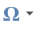
Special symbols
Click on “Insert” then this icon at the right of the ribbon at the top:
Enter below one Greek letter, the symbol for infinity, and a minus sign (note that it is longer than a dash).
∆, ∞, −

Tables
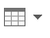
Click on “Insert” then this icon at the left of the ribbon at the top
Data should always be orderly displayed in tables, including proper labels and units. However. If you are gathering data by hand (not using Veriner Graphic Analysis) you can enter the data in a table and if you want to subsequently enter it in Vernier Graphic Analysis for curve fitting and graphing, you can cut and paste the data rather than tediously reentering the numbers. Likewise, if you have some data in Vernier, you can cut and paste it into a table on word.
In section 4 of this lab, we will go over the Vernier Graphic Analysis basics. Insert a 2x2 table here with some numbers in it:

6 | 7
6 | 9

Equations
Click on “Insert” then this icon at the left of the ribbon at the top
Insert below the following formula:
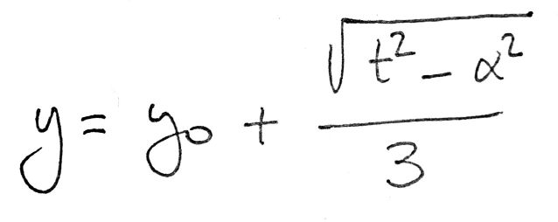

$y=y_{0} + \frac{\sqrt{t^{2}+α^{2}}}{3}$

For long calculations, it is perfectly acceptable to do them on paper and insert a (good) photograph of the calculations. Even better: use a scanning app (like Adobe Scan) to turn the photograph into a clean scan before inserting it.
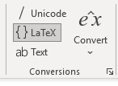
It is NOT acceptable to use hard-to-read options like sqrt(t^2-alpha^2)/3. Your instructor is a regular human whose brain does not run on HTML.
Note: For those who are familiar with it you can also use the MathType addon. Click “MathType” and then to add a MathType equation. MathType also has an option to allow you to compose equations in TeX by inputing $<TeX code>$. In Word you can also insert an equation in TeX by using insert equation as above but on the “conversions” box select LateX. Enter the equation in as a TeX string then under the convert item select “Professional”

Sketches and Snipping Tool
Digital notebooks are convenient and green, but sometimes we just need space to sketch things. Each lab computer has a small graphical tablet or a mouse to draw sketches and diagrams.
You can also do your sketches on a piece of paper and insert a (good) photograph.
Microsoft Word has a tool called Draw or Ink Tools, depending on the version. Using this tool, you can now draw anywhere on the page. Click on “Draw” then select the pen you want to draw with. When done select the big arrow at the left. The eraser pen allows you to remove lines you have drawn.
Draw something below.

Sometimes you will just want to transfer an image (like a snapshot of a graph) to the notebook. You could always save a JPG or PDF file and then insert it in the Word document. However, there is an easier and faster option: You can add screenshots to your file in two different ways:
Within word click “Insert” and select Screenshot 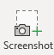 . This brings up a menu which allows you to do either a screen clipping or take a snapshot of another active window on your desktop. If you click on a blank spot in your document, select the “Screen Clipping” tool, then your word document is temporarily hidden and you can use the mouse to highlight a portion of the desktop which will be inserted. After it is inserted, you can resize or crop the image as desired.
You can activate the windows snipping tool by holding down [Windows button]-shift-s. You can then highlight what you want to insert, click in your document where you would like to place the image and hit cntl-s. The image will be inserted. You may then resize or crop the image as desired.
In some versions of Word the F10 or “prt sc” button is equivalent to windows-shift-s.
Insert a shot of something on your screen below.

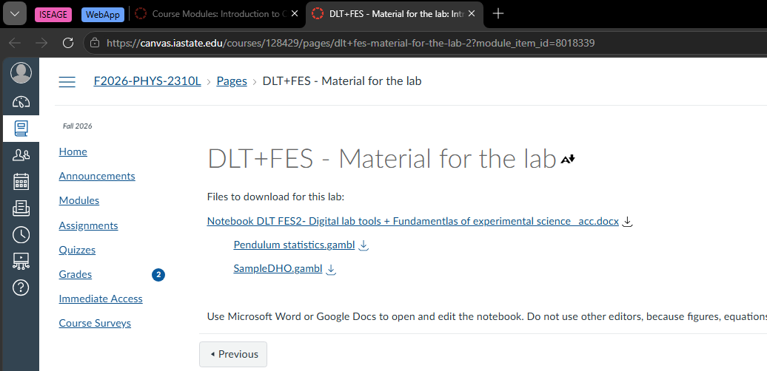

Data collection
Data will be collected from a variety of sources. The methods go from simple processes like reading a ruler, all the way to digital sensors connected to the computer. When sensors are used, the data is automatically collected in a software called Vernier Graphical Analysis. This software is in all lab and help room computers, and we will use it for data analysis.
You can also download and install Vernier Graphical Analysis on your computer. You can either install it on your computer or use the web version. The links and instructions to do so are at the bottom of the home page on Canvas, under “Helpful stuff”.
Alternative software: once you are home, you are allowed to use other data analysis software of your choice to complete the data analysis. We provide some basic guidance for Google Sheets (see “Helpful stuff” on Canvas), but instructors might not be able to help you with alternative software. Please note that while in the labs, you should use Vernier Graphics Analysis.

Verner Graphical Analysis: collecting data through sensors
Whenever we use sensors that send data directly to the computer, you will need to use Vernier Graphics Analysis for data collection.
If you open the program from the icon on the screen, you will get one of the following two starting screens
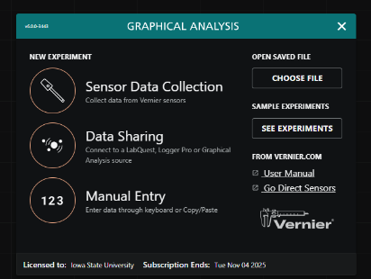
Figure 1: The usual Verner Graphical Analysis starting screen
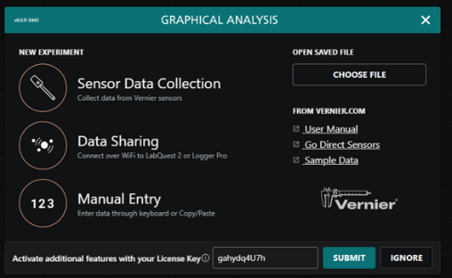
Figure 2: Starting screen with license update. Usually hit submit if the license key is pre-entered as in this case. The license key must be reaffirmed with this screen every two weeks.
Usually, you get the starting screen in Figure 1 and from there you can select “Sensor Data Collection” or “Manual Entry”. If the sensors are hard wired into the lab computer then it will go to “Sensor Data Collection” automatically. “Manual Entry” means that all the data the program uses are entered by hand rather than gathered by sensors. Occasionally you might get the screen in Figure 2 with the “Activate Additional Features with your License Key” at the bottom. The key will generally be automatically filled in so you should just hit the “Submit” button. If that doesn’t work, use the key posted on Canvas or ask your TA for the key; fill it in and then submit (we will want to use the “additional features” in many labs).

License entry from other screens
Occasionally, the program might ask for the License for “Pro” mode. If this happens, click on the three dots at the top right of the screen; click “About” from the drop-down menu. Your license key should already be sitting in the license update box, if so hit the “Submit” button. Otherwise get the key from your TA, enter it in the box and then hit “Submit”.

Dark mode Light mode:
If you click the three dots at the upper right of the screen, you get a drop-down menu. One of the items allows you to switch between “dark mode” and “light mode” with the 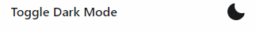button. Switching it to light mode is helpful if you want your screen shots to print more easily. I will generally use light mode for snapshots in the lab manuals.

If a .gambl file(s) is provided on Canvas for the experiment, use that file to open the software, to ensure that you are working with the appropriate predefined settings. In some cases, the Vernier Graphical Analysis program can detect the sensors attached to the computer and will generate default settings which are appropriate for the experiment so downloading a .gambl file is not necessary.
Example: On Canvas, this lab’s module includes a file called SampleDHO.gambl. Download it and open it. In a “real” lab, this will simply provide the appropriate settings for Logger Pro. In this case, we also included some data.
What is the title of the graph? Enter it in the space below.

Dampened Harmonic Oscillations

No sensors
If the data is collected manually, you should enter it directly on Vernier Graphical Analysis in Manual Entry Mode (more details on the software below).

Data analysis

Basic Vernier Graphical Analysis tools
Open the file Verner Graphical Analysis help.pdf. This document is included next to this notebook, but it is also posted under “Helpful Stuff”. You can also get to it in the program from the three dots menu by hitting “User Manual”
The following tasks will guide you through the most basic procedures in Vernier Graphical Analysis.
Before starting, you should click on the icon 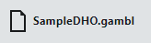 at the upper left then click on “Save As” on the dropdown menu. This allows you to save the file with a different file name so that when you save your work, you don’t overwrite the original file and it can conveniently copied to CyBox or email it so you can have the data for additional analysis in preparing your final draft.

Modify tables and enter data
On the table, click on the button at the right of the Time column.
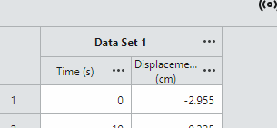
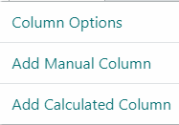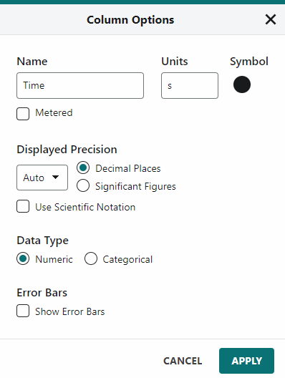

Select “Column Options” from the pop-up menu, change the units to minutes. Also set the column to display two decimal places by changing the “Auto” option under “Displayed Precision” to 2 like this:
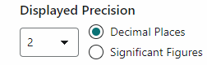
(then hit “Apply” at the bottom)
Open the Column Options on the Displacement column. This is a Manually entered column. In the menu change the Point symbol to a different shape and select a different color.
You can add an additional column to the right of a given column by clicking on the three dots and then either “Add Manual Column” or “Add Calculated Column”, To the right of Displacement add a manual column with the following parameters:
Name: Time 2
Units: s
Once the column is created, add 5 random values between 0 and 10.

Likewise add an addition Calculated Column to the right of “Time 2”, with the following parameters:
Name: Displacement 2
Units: m
Expression: 3*”Time 2”+2+sin(“Time2”)
To enter the expression, click on 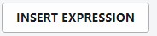 and at the bottom of the list of canned expression click on 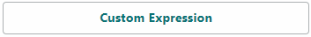 where you can enter the expression as 3*”Time 2”+2+sin(“Time 2”)
Variable names should be in quotes as shown; of the variable name is wrong or you have the wrong type of quote marks that will generate an error. Usually if you type the first few letters of a variable name the software will generate a menu of options which you can select so you don’t have to worry about getting the syntax correct.
Note on trig function: The built-in trig functions evaluate in terms of radians. If you want to enter the angle in degrees, you can multiply the angle in degrees by pi/180 (within Vernier Graphical Analysis the variable pi is defined to be π=3.14…). For example, in the above expression if “Time 2” were in degrees, the final term should be +sin(“Time 2”*pi/180) also note that “*” for multiplication is often optional but be careful.

Modify graphs
Click on the Graph Options icon  at the lower left of the graph. Scroll to the bottom of the popup menu and click on 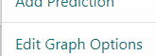”Edit Graph Options” giving the following menu
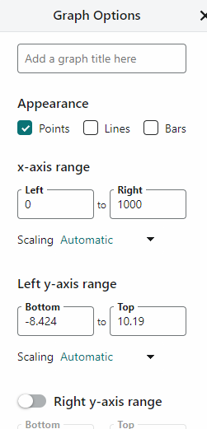
Change the title of the graph to whatever you fancy.
Explore the “Appearance” option. As you can see, the connecting lines can be misleading if the data is not “in order” (in this case, note in the table that t = 100 and t = 200 are in the “wrong” places.)

Scaling of the graph: you can modify the range of the horizontal and vertical axes manually by entering the range under the “Edit Graph Options” menu. Make the horizontal range [500,800] and the vertical range [-5,5]
You can restore the default of including all data by clicking on the Zoom icon at the lower left. Try this.
You can also zoom into a specific part of your data by dragging your mouse horizontally across the graph highlighting a range then clicking on the Zoom icon (The same icon as above except the icon changes its color when a selection is highlighted).
Zoom into the time range [400-600]
Return to the default by clicking again on the zoom icon. Most of the time you probably want to use the default scaling but sometimes it is useful to focus on a part of the graph.

Data analysis tools
Examine: If you click in the graph (be careful not to click-drag) a vertical ruler appears which allows you to directly read the value of the data at any point. Try this.
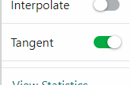
Tangent/Slope: At the top of the “Graph Options”  menu you can find the estimated slope of your data by turning on the “Tangent” switch at the top of the menu. This tool reads out the slope of the tangent (i.e. the derivative)
If you click on a point or drag the vertical ruler which appears to a point it will draw in the tangent and calculate the slope based on that point and the nearby points. Look at the tangents for a few points
Linear Fits are by far one of the most commonly used data analysis tools. Of course, they only make sense if the data shows or at least is expected to show a linear trend to begin with!
For this purpose, let us graph the two columns we created, “displacement 2” and “time 2”.
On the graph click on the horizontal caption and adjust it to “time 2”. Likewise adjust the vertical caption to “displacement 2”.

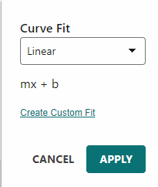
On the Graph Options menu select “Apply Curve Fit”. From the type of fits available select “Linear” (which is the default). In most labs this is the kind of fit we will use.
Now select the “Apply” button. A fat line will appear through your data, this the best line which matches your data. A box appears which is attached to the fitted line containing information about the fit. Click on the Gear icon at the lower right of the box and select show uncertainty of fit parameters. Always do this when you are using the fit for a lab.
A linear fit finds the values of m and b so the equation y = mx + b is the closest approximation to a given set of data. It also determines the correlation r. A good linear fit should have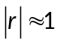 (note 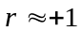 for a positive slope, 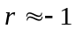 for a negative slope, in general $-1≤r≤+1$).
Insert below the graph including the Linear Fit box showing errors.

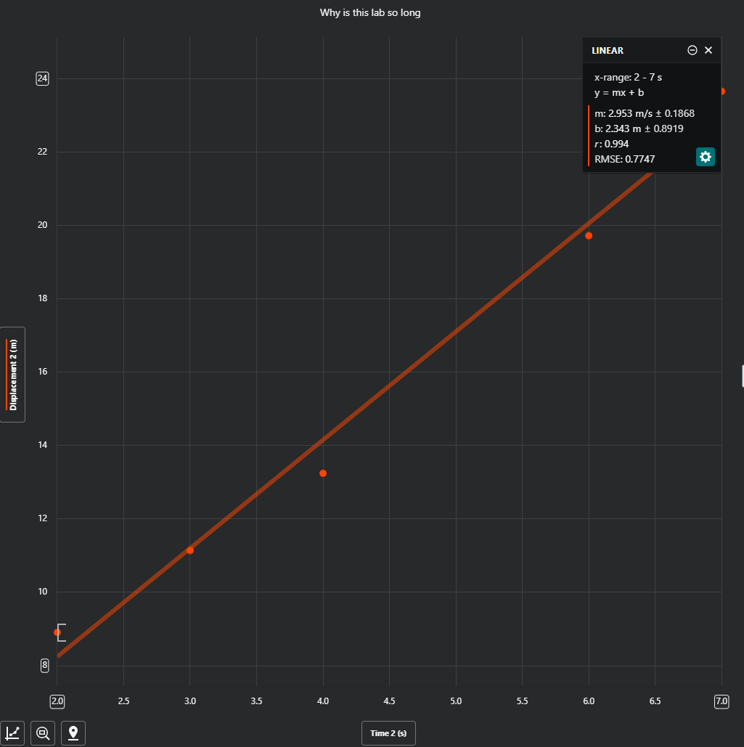
Yeah, because r is close to 1 and this is a positive slope so r is also positive ( -1 ≤ r ≤ +1).
It also uses the formula for y which is y = mx + b, and finds m and b too.
Are the parameters of the linear fit consistent with the formula used to generate the x2 column? Explain.

Inserting Vernier Graphical tables and graphs onto the notebook

Data table

Method 1: using screen shot
The Snipping Tool (command-shift-s) or Insert→Screen Shot→Screen Clippings and place the image of the file into your word document.

Method 2: using tables
Highlight the portion of the Vernier Graphical Analysis data table you wish to copy. Copy it with cntl-c. Click on the spot where you want to place the data and place the data as plane text there by hitting cntl-v. Within Word, highlight the data, Hit “insert” then select “tables” 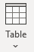. From the dropdown menu select “Convert Text to Table” . In the box that appears click “OK”. You will then have to add a row on top for the column heading since the column headings don’t get copied. This is more useful if you want the actual numbers in your lab book rather than just an image of the table. The numbers are non-rounded so contain excessive insignificant figures.

It is also possible to cut and paste data from a word table into A Vernier Graphics Analysis table. To do this highlight a column of data in the Word table then copy it with cntl-c. Next click at the top of a blank column in Vernier Graphics Analysis and past with cntl-v. Repeat for each of the data columns.
Insert a table of Time 2 and Displacement 2 below using one of these methods:

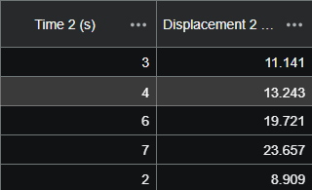

Graphs
The graphs can be copied into word with a screen shot; either the Snipping Tool (command-shift-s) or Insert→Screen Shot→Screen Clippings is once again the easiest way.
Insert below a capture of the two graphs together. To get two graphs select the view options button in the upper right and from that menu select “2 Graphs” Adjust the captions of the second graph to show “Time” and “Displacement”.
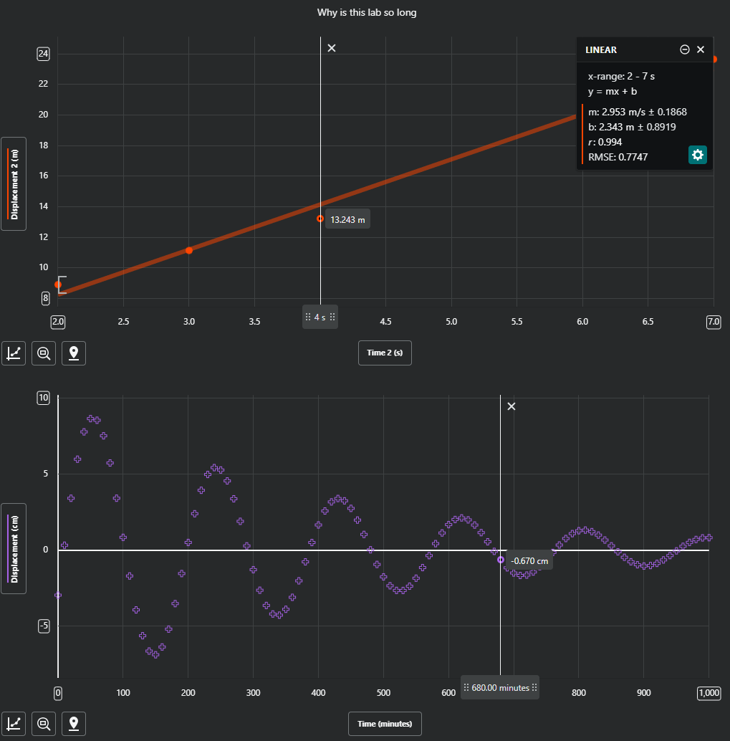

Axis Labels for Graphs
Whenever you include a graph in a lab book, the axes must be labeled and units given (if applicable) and there must be a Title. Points will be removed if these items are not included. You can have them inserted in Vernier Graphical by setting the name and units in the column definition (better) or add them later with an appropriately placed text box in Word (OK) but do not neglect to provide such labels.

Saving your work

Each lab partner should take home a copy of all the material produced during the lab (not just the notebook!). You can use CyBox, your Google drive, a flashdrive, or email yourself the files.
“My partner was supposed to send me the data but it never happened” will not be accepted as an excuse. The files which you should copy are: the lab book with data, observations and calculations you made during the lab and any .gambl file your group produces with data from the lab.

Submit lab notebook
At the end of each session and before leaving the lab, each student must submit the notebook (.docx or PDF) as it is at that moment to the corresponding “First draft” Canvas assignment.
This is an individual process. It is NOT acceptable to do one submission per group. Each student needs to submit one first draft.
At this time you can also submit any data files you have generated in the lab through the “Data Files” item in the module. Submit here any .gambl or other files you have generated in the lab. This item is not graded directly but could be helpful to you if you want to reanalyze or re-graph the data you collected in the lab and is helpful in figuring out where you might have gone wrong if your results are not what they should be.

This is the end of the introduction to the Digital Lab Tools. This notebook contains another activity below (Lab FES) that you must also complete before your submission.

Lab FES - Fundamentals of experimental science

Metrology
In the prelab, you watched the minilecture video Metrology.

Resolution, range, best estimate, error
In experiment B in the Metrology slides, we used a mechanical balance with 0.1-g calibrated masses to measure the mass of a sample.
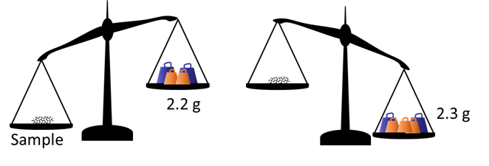
Assuming that the balance works properly and that the scale masses are very well calibrated, write below the result of this experiment with 100% probability:
- As a range
- As a best estimate ± error.
- As a best estimate ± percentage error.
Range: 2.2 ≤ M ≤ 2.3
Estimate Error: 2.25 ± 0.05 g
Percentage Error: 2.25 ± 2.222%

As a rule of thumb, the uncertainty can be taken as half of the resolution of the equipment.

Other scales

Digital scale
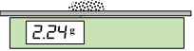
We instead place our sample on a digital scale and obtain the reading shown to the right.
Would this scale allow you to differentiate between samples with masses 2.241 g and 2.2386 g? Explain.
No because the digital scale only shows upto 3 significant figures. 2.241 g and 2.2386 g will both be rounded to 2.24 g

How far below 2.24 g could the value be (with this reading on the display)?
It will round up anything including and above 2.235 g to 2.24 g. So 0.005 g below.

How far above 2.24 g could the value be?
It will round down anything including and below 2.2449 g to 2.24 g. So 0.0049 g above.

Using these two limits above and below, write the measurement as a range, and then as a best estimate ± uncertainty.
Range: 2.235 ≤ M ≤ 2.2449
(2.24 ± 0.005) g

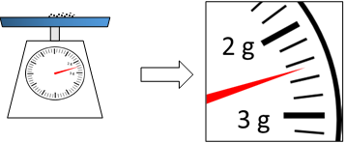
Dial scale
The figure to the right shows what the reading would look like if we used a dial scale.
What is the smallest amount you can discern on the dial: 0.2 g? 0.1 g? Maybe even 0.05 g?
In this case, resolution depends on the ability of each experimenter! And that means that experimenters will also produce a slightly different uncertainty (which is half of the resolution, remember the rule of thumb defined at the end of section 1.1).
Let’s settle for a resolution of 0.1 g. Write the reading above as best estimate ± uncertainty.

(2.5 ± 0.1) g

As you can see, the determination of uncertainty can be a complicated issue –and it will get worse in a while once we start talking about probabilities. For the purpose of this class, we want you to be able to obtain some estimate of the uncertainty that you can reasonably justify. Our main goal is that you understand why uncertainty must always be part of the result.

Significant figures
Let us imagine that we want to estimate the thickness of a sheet of paper.
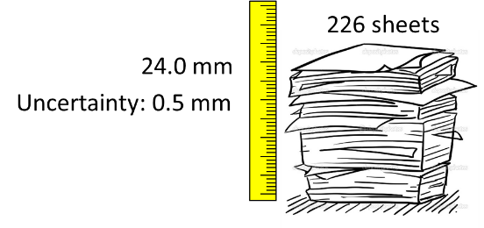
So we take a pile of paper, we count the number of sheets, and obtain 226. Then, we measure how tall the pile is with a ruler: 24.0 mm.
As discussed in section 1, we could have a long argument about how exactly the uncertainty of this measurement should be. Let’s settle to ± 0.5 mm
Then, is this the proper way to calculate the thickness of the sheet (with error included)?
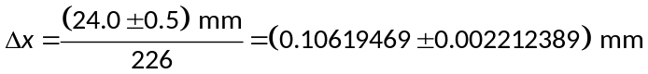
Explain what is wrong with this result. Rewrite it with a meaningful number of significant figures and explain your reasoning.
Result: (0.106 ± 0.002) mm
Reasoning: Divide the total thickness (24.0 mm) and its uncertainty (0.5mm) by 226 sheets. Rounding the uncertainty and the thickness, we get the result.

Statistics

A simple pendulum
If we hang a small weight at the end of a light string, we obtain a so-called simple pendulum. This is an example of an oscillatory system. The time the weight takes to move back and forth once (i.e., to go through an entire cycle) is called the period, T, of the system.
Let us assume that we repeat the following experiment 20 times: we displace the pendulum from its equilibrium position until the string forms an angle of 15° with the vertical and release the system from rest. Using a stopwatch with a resolution of 1/100th of a second, we measure the period of the oscillations in each repetition. The results are shown below.
Event | Period (s)
1 | 2.02
2 | 1.94
3 | 1.94
4 | 1.92
5 | 1.73
6 | 1.73
7 | 1.41
8 | 2.18
9 | 1.84
10 | 2.11
11 | 1.84
12 | 1.53
13 | 1.80
14 | 1.87
15 | 1.68
16 | 2.02
17 | 1.99
18 | 1.99
19 | 2.02
20 | 1.56

Since the variations between measurements are much more important than the resolution of the stopwatch, we will not worry about the error associated with the apparatus.

This data is in the file Pendulum statistics.gambl, but we just copied the numbers. Download and open the file on Vernier Graphical Analysis. Then, relabel X and Y to “Event” and “Period”, and include the proper units. In the graph, either
Select all the points then click on “View Statistics” in the menu that pops up
OR
Click on the graph options icon at the lower left  and then select “View Statistics”.
The software will then calculate the average and standard deviation of this data. You can use this to calculate the standard error. Enter your table, calculations and results below. (Remember to save the .gambl file for your records.)

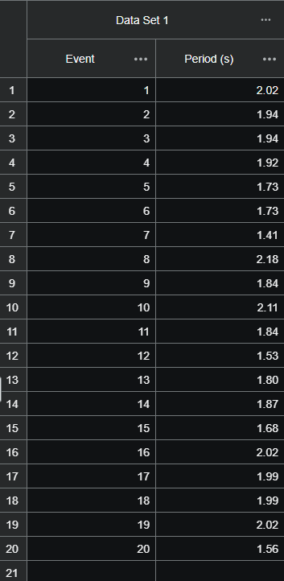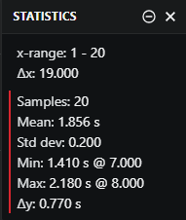

Standard Error: 0.045

The standard deviation is a measurement of the variations within the sample. It should not depend much on whether we repeat the test 10, 20 or 100 times. However, notice that the standard error has a $\sqrt{n}$ in its denominator, where n is the number of measurements. In general, what happens to the standard error when n is very large?

It will decrease as it will approach zero (when n is very large the denominator will be very large).

This is one of the reasons why repetition is a crucial element of reliable measurements! Can you suggest another?

Precision is another crucial element to reliable measurement.

Later in the semester, you will learn that the period of a simple pendulum for small oscillations is given by:
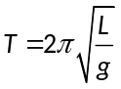
where L is the length of the string and g is the acceleration of gravity (g = 9.81 m/s²)
Let us imagine that we measure the length of the string of our pendulum and obtain 89 cm. Using this value and the formula above, what is the theoretical expected period for this pendulum?
1.89 seconds

Is the experimental value of the period consistent with theoretical value? Explain.

Yes, they are consistent. Our experimental range is 1.856 ± 0.045 s. The theoretical value of 1.89 s falls right inside this margin of error.

